Git and Github

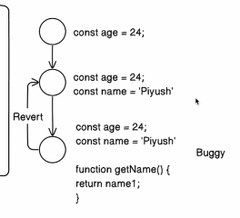

There are more software’s like Apache and Piper but we use Git and Github because 99% companies use this.
Git tracks the changes that you made in your code.
SCM – source control management
VCS – version control system
On CMD –
git - check if git is installed
git -v – check git version
git cheat sheet - https://education.github.com/git-cheat-sheet-education.pdf

Setup –
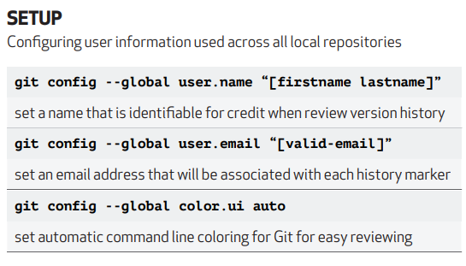
Why do we setup?
So, every time we made a change in our code, git tracks who made the changes and that is why we need to set the global config.

dir : lists all directories
cd dir-name : change directory
mkdir : makes directory
starting –
git-init – initializes the git in the current directory
Initialized empty Git repository in C:/Users/SONY/Desktop/Coding/git-course/.git/ // output example
As soon as you git init; now U is marked in front of the file
U means – it is untracked ; project is git enabled but untracked
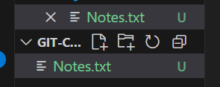
A hidden folder will get created named as .git and all the tracking is saved in this folder
Start Tracking –
git add file-name– enable tracking your file
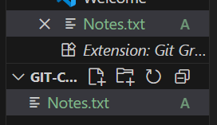
Now the symbol changes to A that means additions are tracked
When you save the symbol changes to M
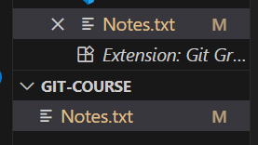
git diff – tells what changes are made
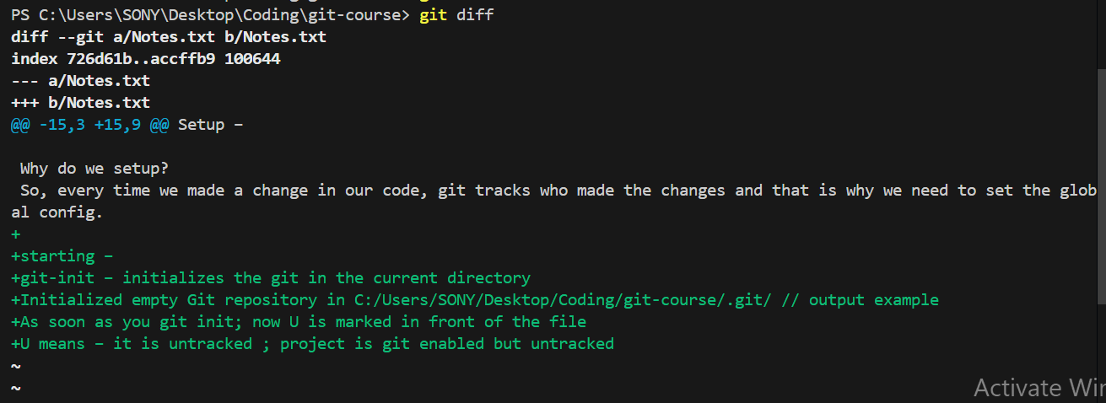

git add . – to add all files of current folder
git rm file-name – removes the files that from tracking
Commits –
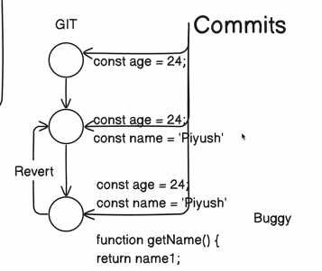
So when we start making changes in our code and when we finish making the changes we do commit.
We do following –
git add . – to add all files
git -m commit “Initial Commit” – to commit
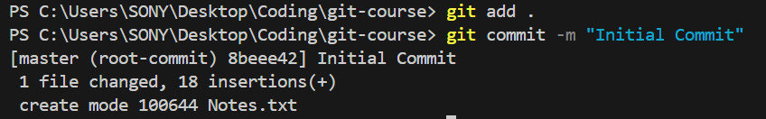

git log –
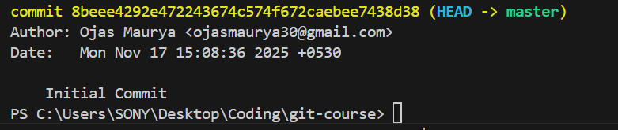
If we do more changes
Do git add . and then git commit -m “commit name”, then git log to check all commits

git log –oneline – create the short id for commit
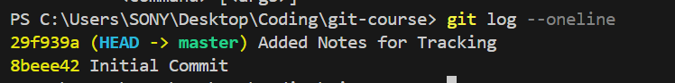
git show id – shows what changes are made in that commit
git blame file-name – to check which user made what changes

Staging Area –
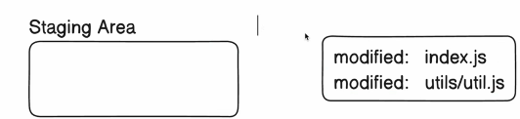
git status – if you modify a file it will tell that file is modified
When we make changes to a file we need to move them to staging area.
git add “file-path” – this move the file to staging area
git commit -m “commit-name” – the file that you moved to staging area only that will be commit

Reverting Back Commits –
All the commits are stores as nodes in a linked list and the head always points to the latest node.
git reset –hard “commit-id” – head will move to the given commit id
If you want to revert some changes that you made earlier in any commit –
git revert “commit-id” – It will revert the changes made in the given commit
git commit -m “revert” – It will make a new commit with the latest changes made in revert and move head to this node.
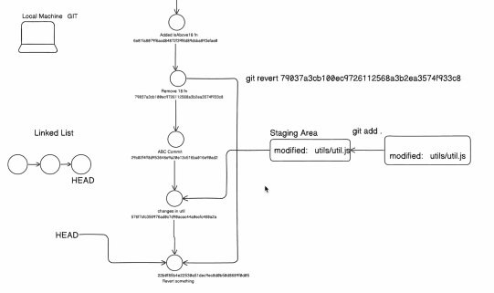

Collaboration with Git and Github –
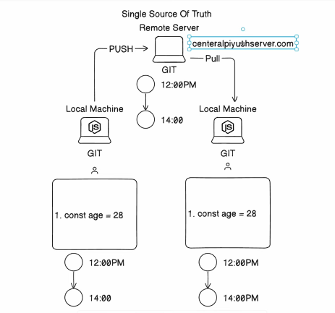

Github is central server for git.
GitLab and BitBucket are some examples of central servers.

Adding your code on Github –
Create a repository
git remote add origin “link-of -your-github-repo” – link your local machine git folder to the github repo
git push -u origin main – push your current code to github
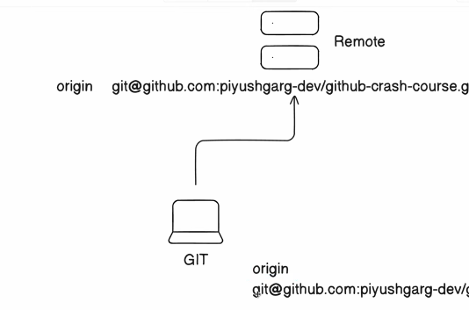

Generating private and public SSH keys –
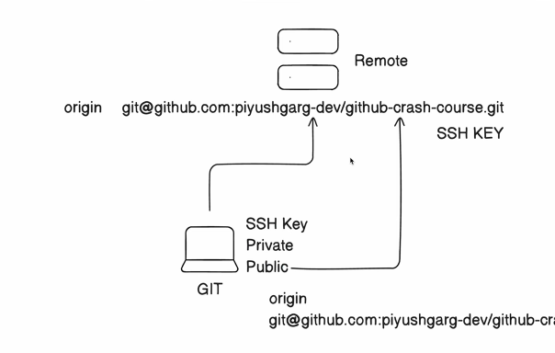

These keys are generated so that it will authenticate the user who is pushing the code.
To generate a ssh key locally
ssh-keygen -t ed25519 -C your_email@example.com
Copy the public key to your github account

git push -f - If you revert back to any previous commit we need to push forcefully –

Branching in git (Very Very Important) –
While working on collaborative environment we should never work on the main branch
Create a new branch like below -
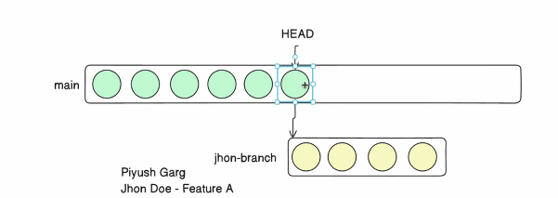

When the user finishes the work all the changes of branch get commit in a single commit to main
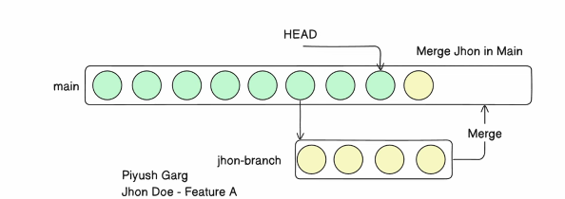

How to make the branch –
git branch – to check the current branch
git branch “branch-name” – create a new branch
git checkout “branch-name” – to switch to new branch
git push --set-upstream origin “branch-name” – to push

Merging the branch with main Using Cli -
git checkout main
git merge origin/branch-name
Merging on Github Using Pull request –
Create a pull request
Maintainer will merge –
git pull – on to pull all new changes
git checkout -b “branch-name” – create a new branch and switch
Branching name convention –
git branch “feat/add-chat-support” – means that it’s a feature and we are adding chat support
git branch “bug/login-not-working” - fixing a bug

Git Visualtization – website to visualize how git works

Rebasing –
Merger the branch with the head of main branch
Create a new branch and make several commits
git rebase branch-name
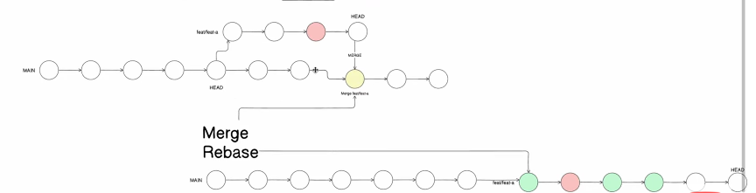

Stashing –
If some one made changes in code in Origin
And you are making changes in your local code
And you want to pull the changes made in origin
You can’t do it as the current changes on local code are not commit or stashed.
Use –
git stash – saves the local changes in a temp directory
git pull – pulls the changes from origin
the use
git stash apply – apply the changes that you were working on

